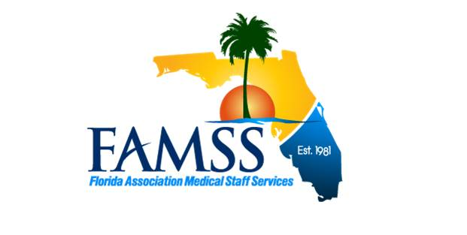
ANNUAL AWARDS NOMINATION FORM
Submission Deadline is March 1, 2023

Check one: Advocate of the Year Mentor of the Year Sylvia B. Davis Scholarship
As a FAMSS member in good standing, I hereby nominate the following individual for the annual award indicated above. Please refer to the eligibility criteria. You may attach additional pages if you need more space. Members of the FAMSS Board of Directors are not eligible for nomination.

Nominee’s Name

Demographic Information
Nominee’s Title
Nominee’s Organization
Mailing Address
Phone: | E-mail: | Fax

Describe nominee’s efforts to support local, FAMSS and NAMSS membership:

Describe nominee’s networking/mentoring efforts:

List nominee’s educational presentations and/or articles written:

This nomination is submitted by:
Signature: |  | Date:
Printed Name:

Organization:

Phone: | E-mail: |  | Fax:
Please return the nomination form to:
FAMSS Press Secretary at
SusanTanenbaum@Hotmail.com
Or mail to:
Susan Tanenbaum, CPCS, CPMSM
2823 Cedaridge Drive
Tampa, FL 33618

ANNUAL AWARDS 2023
The FAMSS Board may present any or all of the following awards at the annual FAMSS business meeting held during the annual education conference.
- A nomination form will be posted on the FAMSS web site and sent with the annual membership renewal notices. Nominations must be submitted in time for consideration at the FAMSS Board Meeting in March. Current Board members shall not be eligible.

- A FAMSS member in good standing may nominate candidate(s) for an award by submitting a narrative (not to exceed 500 words), including the following information:
  - Nominee name, organization and position name;
  - Nominee’s mailing address, phone number and fax number;
  - Description of nominee’s contributions to FAMSS.
- Once submitted, all nominations become the property of the FAMSS Board and will not be returned. FAMSS reserves the right to reprint the nomination and photographs in FAMSS publications and on the FAMSS web site.

- It is the responsibility of the individual submitting the nomination to ensure it is completed and submitted within the time frame designated on the FAMSS Annual Awards Nomination Form,
At the March Board Meeting, the FAMSS Board will evaluate all nominations. The Board will determine if any or all of the awards are to be presented at the annual FAMSS Business meeting held during the annual education conference.
The three awards are:

FAMSS Advocate Award
The FAMSS Advocate Award(s) recognizes professionals for the contributions they have made to FAMSS. The recipient shall receive a recognition award, one (1) night’s lodging and travel expenses per the travel policy, for the recipient only.

FAMSS Mentor Award
The FAMSS Mentor Award(s) was established to recognize FAMSS members in good standing for their mentoring efforts. The recipient shall receive a recognition award and a two-day conference registration. The recipient will be invited to attend the luncheon to accept the award.

FAMSS Sylvia B. Davis Scholarship Award
The Sylvia B. Davis Scholarship Award was established to recognize FAMSS members for their efforts at the local chapter and state level. The Award is a scholarship to cover the cost of the recipient’s two-day conference registration, lodging and travel in accordance with FAMSS Travel Policy to be redeemed within two (2) years. Candidates must be FAMSS members in good standing who have demonstrated enthusiastic support of FAMSS and NAMSS.
Reference: FAMSS Policy and Procedures January 2019.

